31.56: a) 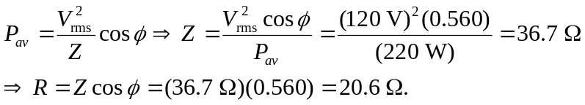
b) But at
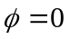this is resonance, so the inductive and capacitive reactances equal each other. So:
c) At resonance, 